- Select the items in Desktop that you would like to export. You can select consecutive items by clicking the first item, holding down Shift, and then clicking the last item. To select items that are not consecutive, press and hold down Ctrl then click each item.
- On the File menu, point to Send To, and then click Directory. As an alternative, click on the toolbar.
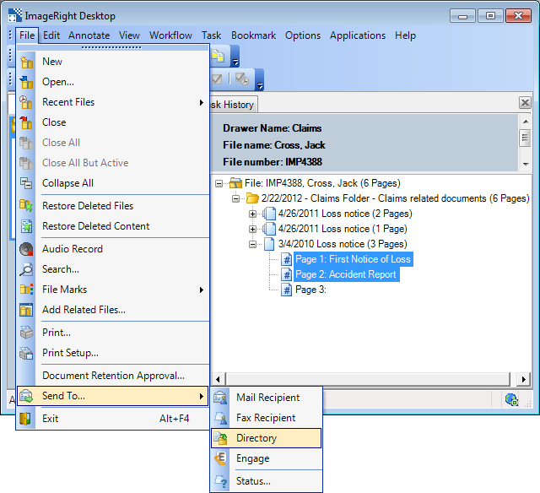
- The selected items will appear in the Convert or Send as Native list. If you don't see the Send as Native list, clear the Include Export Viewer option at the bottom of the dialog box.
  - The items in the Convert list will be converted to the format that you select as explained later when exported.
  - Items in the Send as Native list will not be converted. This means you can export items in their native format. For example, you can export a word processing document without it being converted to PDF. If you send a document in this manner, the person receiving the document will be able to edit the document as needed, provided she has access to the related program.
- To move items between the lists, simply drag them from one to the other and drop them in the appropriate location. The yellow arrow indicates the placement of the item being moved.
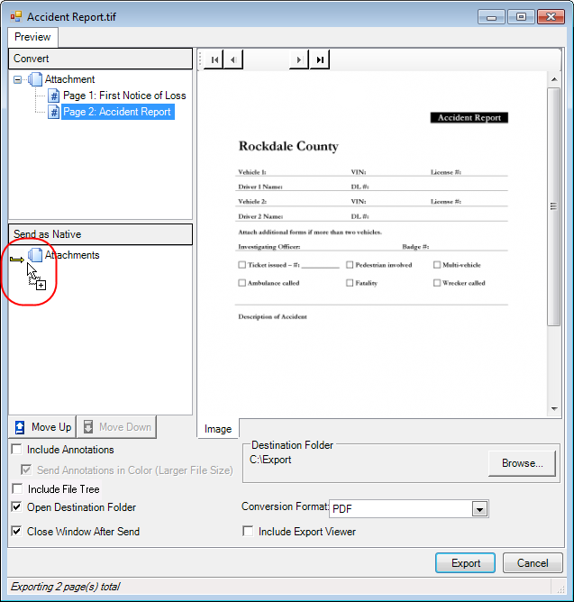
- You can drag items from an ImageRight file and drop them in the list of attachments.
  - Move the Send To Directory dialog box so that you can see Desktop.
  - Open the file that contains the items that you want to export.
  - Drag the items to the Convert or Send as Native list. The yellow arrow that appears will help you position the items. When the menu appears, choose the correct command for the final placement of the attachments. If the menu doesn't appear, clear the Include Export Viewer option, and start the drag operation again.
    - Insert in Current Attachment and Position to place the images between others
    - Append to Current Attachment to place the images in the last position of the attachment
    - Create a New Attachment to add another attachment to the list to which items can be added
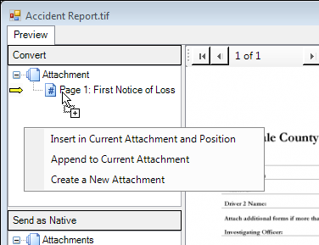
- Based on the descriptions that follow, select the appropriate options at the bottom of the dialog box.
  - Include annotations – Annotations on the selected items will be included in the exported copies.
  - Send annotations in color – Included annotations will be in color as opposed to monochrome. The size of the exported file will be larger, so consider the use of this option carefully.
  - Include File Tree – The file tree directory (PDF bookmarks) in a PDF file will be included.
  - Open destination folder – The folder to which the items are exported will be opened automatically.
  - Close window after send – The Send To Directory dialog box will be closed automatically when the export is complete.
  - Destination folder – Click Browse and locate the folder to be used to store the exported items.
    - The Browse for Folder dialog box will open.
    - Locate the directory that you want to use and click OK.
    - Click Make New Folder if you would like to create a new folder. You can right-click the new folder and click Rename if you need to change its name.
    - The path to the directory is remembered until you change it again.
  - Conversion format – Select the format to which the items in the Convert list should be changed when they are exported. The selected format is remembered until you change it again.
    - PDF (Portable Document Format) – A file that can be viewed on different computer platforms using a PDF viewer, typically Acrobat Reader.
    - Single-page B/W TIFF – Each page of each attachment will be converted to a black and white, single page TIFF.
    - Single-page color TIFF – Each page of each attachment will be converted to a color, single-page TIFF.
    - Single-page gray scale TIFF (Tagged Image File Format) – Each page of each attachment will be converted to a non-color, single-page TIFF.
    - Multi-page B/W TIFF – The pages in the attachment will be converted to one black and white, multi-page TIFF, that is, one TIFF for each attachment.
    - Multi-page color TIFF – The pages in each attachment will be converted to one color, multi-page TIFF, that is, one TIFF for each attachment.
    - Multi-page gray scale TIFF – The pages in each attachment will be converted to one non-color, multi-page TIFF, that is, one TIFF for each attachment.
  - Include Export Viewer – A viewer that can be used to view exported files. Typically, the viewer is used by people who do not have ImageRight Desktop installed.
- Click Export to complete the process or Cancel to close the dialog box without exporting the items.
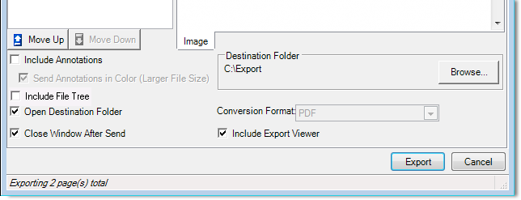
If you selected the Open destination folder option, you will see a folder similar to the one shown in our example. In our example, we exported two items as TIFF images.
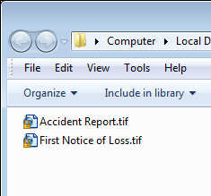
After you have your document extracted from ImageRight, Import them into Indio or another application.
Then delete it from the directory (folder) to keep it clean.
