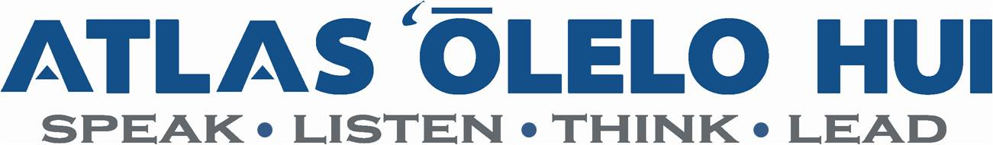
General Evaluator Checklist
The General Evaluator gives feedback to the meeting participants who have not already been evaluated. Here is the opportunity for the Toastmaster, Table Topics Master, Table Topics participants, and the Evaluators to receive feedback on how well they did and to hear suggestions on how to improve. The main focus should be on the Speech Evaluators.
- Review your Competent Leader manual for the project you are working on. Bring your Competent Leader Manual to the meeting and have someone complete the evaluation
- Is anyone filling a special project? If so, incorporate specific feedback during your evaluation. Members should reach out to the General Evaluator to notify you of any special projects.
- Presiding Officer
  - Did the meeting start on time?
  - Were the guests welcomed?
- Toastmaster
  - Were the meeting roles explained?
  - Were guests given an opportunity to introduce themselves?
  - Did the introductions include...
    - a brief biographical sketch?
    - the objectives of the speech?
    - the speech title?
  - Were the transitions between speeches smooth?
  - Did the segues between speeches show that the Toastmaster was listening?
  - Will the meeting end on time?
- Table Topics Master
  - Were the topics appropriate?
  - Were the topics introduced in 1 minute or less?
  - Were any special techniques (e.g., props, gestures) employed?
- Table Topics Participants
  - How has each speaker improved?
  - Were any special techniques (rephrase, artful dodge) used?
  - What, in terms of the mechanics of impromptu speaking, can be improved?
- Evaluators
  - Was the book report summary avoided?
  - Was the 'sandwich' technique employed:
    - Did it begin on a positive note?
    - Was at least one suggestion for improvement made?
    - Were more than 3 suggestions made?
    - Was encouragement added at the close?
Just like a speech evaluation, the general evaluation should neither be a whitewash nor a scathing criticism, but should point out where the club could use some improvement and what we are doing well.


